CO3 ASSESSMENT TOOL 1 – Git & Docker Technical Assignment
Open-Source Contribution Tracker and Recommendation System for Beginner Developers
Course Code: CSA10 / CSA1063
Course Title: Software Engineering
CO Assessed: CO3
Assessment: Assessment Tool 1 – Git & Docker
Weightage: 20%
Total Marks: 25
Student Name: T. Niranjan Kumar
Register Number: 192473007
Date:8/08/26
CO3 Statement
Build full-stack applications with an emphasis on containerization, version control, and collaborative development.
Student Declaration
I certify that this submission is my original work and that I have followed the academic integrity guidelines specified for this assessment.
Signature of Student: T. Niranjan

S.No. | CONTENT | PAGE NO.
1 | Introduction | 1
2 | Problem Statement | 2
3 | Objectives | 3
4 | System Architecture | 4
5 | Frontend Development | 5
6 | Backend Development | 6
7 | Recommendation Module | 7
8 | Dockerfile Development | 8
9 | Docker Compose Configuration and Container Execution | 9
10 | Testing and API Verification | 10
11 | Results and Screenshots | 11
12 | Conclusion | 12
13 | References | 13

1. PROBLEM ANALYSIS
1.1 Industry Context
Open-source software has become an important part of modern software development. Beginner developers can gain practical experience, learn collaborative development practices, build a public portfolio, and interact with developer communities through open-source contributions.
However, the large number of repositories available on platforms such as GitHub can make it difficult for newcomers to identify projects and issues that match their skills.
1.2 Problem Statement
Beginner developers often find it overwhelming to identify suitable open-source projects because repositories differ in technology, complexity, activity level, contribution guidelines, and community responsiveness.
Beginners may also find it difficult to track issues, pull requests, and contribution progress across multiple repositories.
Therefore, the proposed system provides a beginner-friendly platform that recommends suitable open-source issues based on the developer's programming skills and tracks their contribution activity.
1.3 Objectives
- Design a recommendation engine that suggests beginner-friendly open-source issues based on known programming languages.
- Integrate the system with GitHub-oriented issue information.
- Provide a centralized contribution tracker for issues and pull requests.
- Visualize contribution progress and contribution activity.
- Provide difficulty information for recommended issues.
- Support future notifications and portfolio-oriented summaries.
1.4 Functional Requirements
- User enters known programming skills such as Python, Java, JavaScript, or HTML.
- System matches issues according to selected skills.
- System displays recommended issues with language, difficulty, label, and title.
- System displays contribution records including repository, issue, type, language, and status.
- Dashboard provides a simple interface for recommendations and contribution tracking.
1.5 Expected Outcomes
The expected outcome is a beginner-friendly platform that reduces the effort required to discover suitable open-source issues and provides a structured view of contribution activity.
The system can later be extended with live GitHub API integration, notifications, advanced recommendation models, and portfolio generation.

2. PROJECT STRUCTURE DESIGN
2.1 Repository Structure
opensource-contribution-tracker/
│
├── backend/
│ ├── app.py
│ └── requirements.txt
│
├── frontend/
│ ├── index.html
│ ├── style.css
│ └── script.js
│
├── recommendation/
│ ├── __init__.py
│ └── recommend.py
│
├── database/
│ ├── __init__.py
│ └── contributions.py
│
└── README.md
2.2 Purpose of Major Components
Component | Purpose
backend/app.py | Flask application, routes, request handling and API responses
frontend/index.html | Dashboard page structure
frontend/style.css | Visual styling, layout, cards and buttons
frontend/script.js | Client-side interaction with APIs
recommendation/recommend.py | Skill matching and issue recommendation
database/contributions.py | Contribution records
requirements.txt | Python dependencies
README.md | Project documentation
[PASTE SCREENSHOT HERE]
Figure 1. Project repository structure in Visual Studio Code
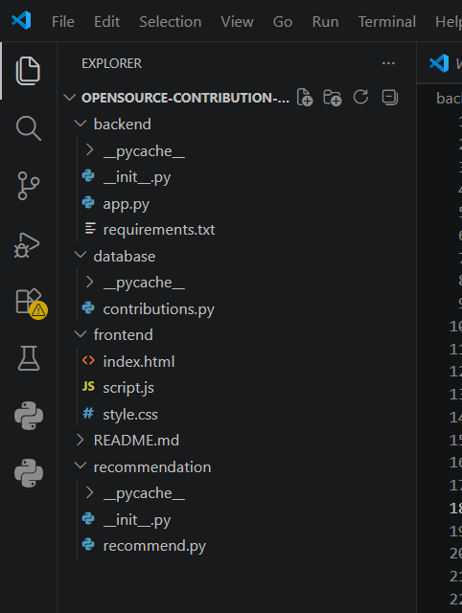
3. GIT REPOSITORY INITIALIZATION
3.1 Purpose of Git
Git is used to maintain the history of source-code changes. It allows the project to be developed incrementally, records meaningful changes through commits, supports branches for separate features, and provides a basis for collaboration.
3.2 Repository Initialization
The project repository is initialized from the project root directory.
git init
git status
git add .
git commit -m "Initial project setup"
git log --oneline
3.3 Explanation of Git Operations
Command | Purpose
git init | Creates a new Git repository
git status | Shows changed and untracked files
git add . | Stages project files
git commit -m | Creates a version-control checkpoint
git log --oneline | Displays commit history
[PASTE SCREENSHOT HERE]
Figure 2. Git repository initialization and initial commit in terminal
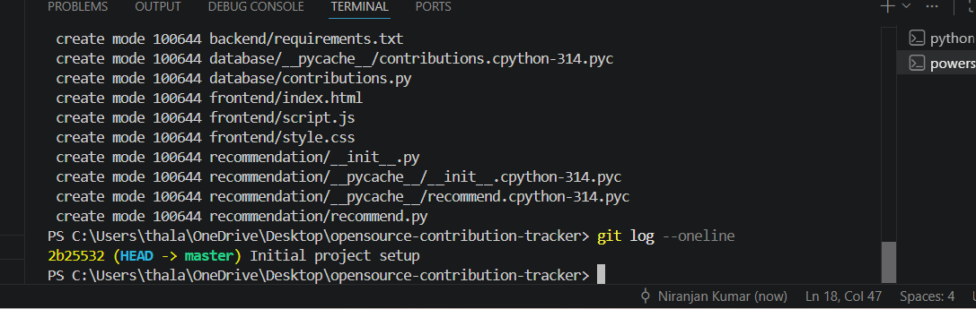

4. GIT BRANCHING STRATEGY
4.1 Selected Branching Model
A simple feature-based branching strategy is suitable for this project.
main
│
└── development
├── feature/backend
├── feature/frontend
├── feature/recommendation
└── feature/docker
4.2 Branch Purpose
Branch | Purpose
main | Stable and submission-ready project
development | Integration branch
feature/backend | Backend API implementation
feature/frontend | Frontend and dashboard implementation
feature/recommendation | Recommendation logic
feature/docker | Docker configuration
4.3 Justification
- Features can be developed independently.
- Changes can be tested before merging.
- Stable code is protected from direct modifications.
- The structure demonstrates professional Git practices.
[PASTE SCREENSHOT HERE]
Figure 3. Git branching strategy / branch list
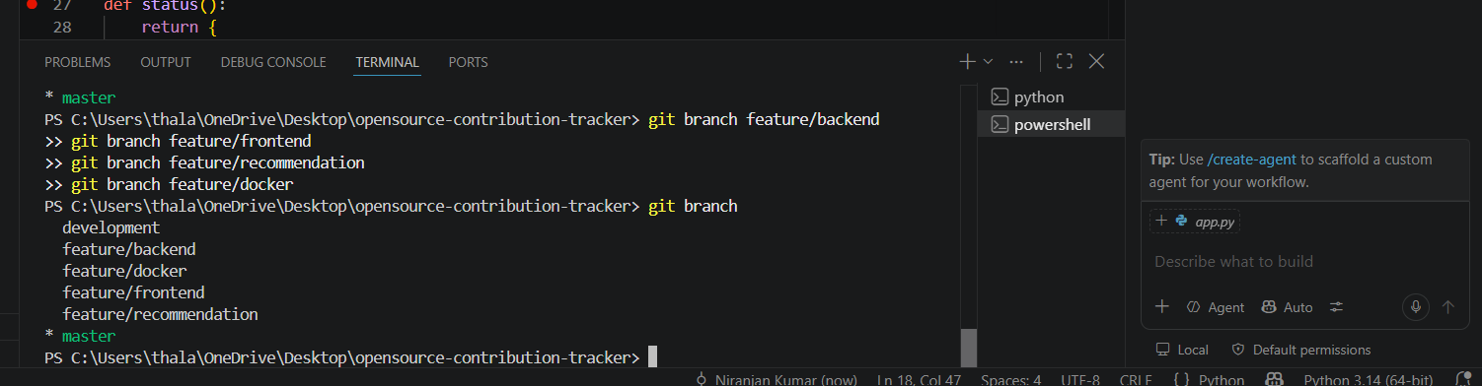
5. VERSION CONTROL WORKFLOW
5.1 Version Control Workflow
Create/Modify
↓
git status
↓
git add
↓
git commit
↓
Branch / Merge
↓
Repository Synchronization
For each meaningful development stage, project files are reviewed, staged, and committed.
Feature branches can be merged into the development branch after testing. The stable version is maintained on the main branch.
5.2 Suggested Meaningful Commit History
- Initial project setup
- Added Flask backend API
- Added skill-based recommendation module
- Added contribution tracking module
- Added frontend dashboard
- Added dashboard styling
- Integrated frontend with backend APIs
- Added deployment configuration

6. COMMIT HISTORY ANALYSIS
6.1 Good Commit Message Practices
Commit messages should be short, descriptive, and focused on one logical change.
Meaningful commit history makes it easier to understand project evolution, identify changes, and maintain the application.
6.2 Repository Synchronization
When a remote repository is used, changes can be synchronized using push and pull operations. This supports backup, collaboration, and access to project history.
[PASTE SCREENSHOT HERE]
Figure 4. Git commit history using git log –oneline
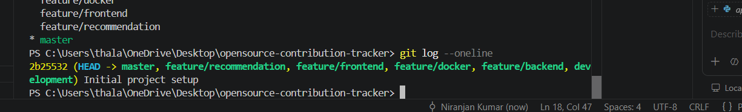

7. DOCKER ENVIRONMENT DESIGN
7.1 Why Docker is Suitable
Docker provides a consistent runtime environment by packaging the application and its dependencies into a container image.
For this Flask-based project, containerization simplifies setup, reduces environment-related differences, and makes the application easier to deploy.
7.2 Components Considered for Containerization
- Flask backend application
- Python runtime
- Python package dependencies
- Recommendation module
- Contribution data component
- Frontend assets
7.3 Container Architecture
The proposed container design uses one application container for the current implementation.
If the system is extended with a separate database or notification service, additional containers can be introduced using Docker Compose.
[PASTE DIAGRAM / SCREENSHOT HERE]
Figure 5. Proposed Docker-based application architecture
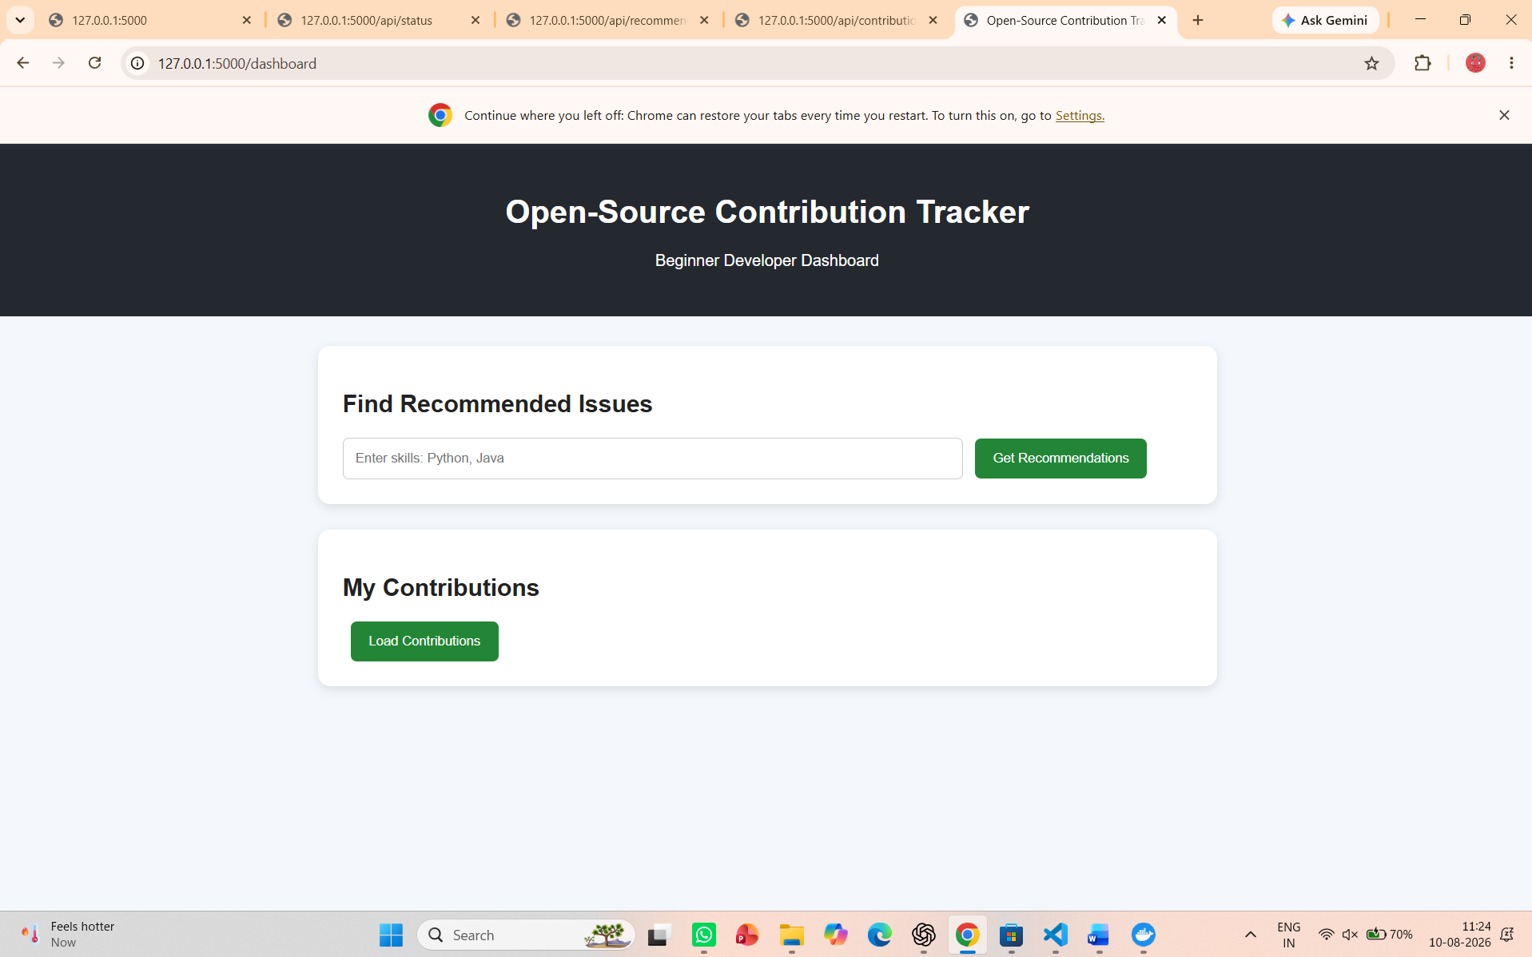
7.4 Benefits
- Portable development environment
- Dependency isolation
- Repeatable application startup
- Simplified deployment
- Separation between application and host environment

PAGE 8 – 8. DOCKERFILE DEVELOPMENT
8.1 Dockerfile Purpose
A Dockerfile defines the instructions used to create an application image.
For this project, it specifies a Python base image, working directory, dependencies, application files, exposed port, and startup command.
8.2 Proposed Dockerfile
FROM python:3.12
WORKDIR /app
COPY backend/requirements.txt .
RUN pip install -r requirements.txt
COPY . .
EXPOSE 5000CMD ["python", "-m", "backend.app"]
8.3 Instruction Explanation
Instruction | Purpose
FROM | Selects the Python runtime image
WORKDIR | Sets working directory
COPY | Copies project files
RUN | Installs dependencies
EXPOSE | Documents application port
CMD | Starts the application
[PASTE SCREENSHOT HERE]
Figure 6. Dockerfile implementation in Visual Studio Code
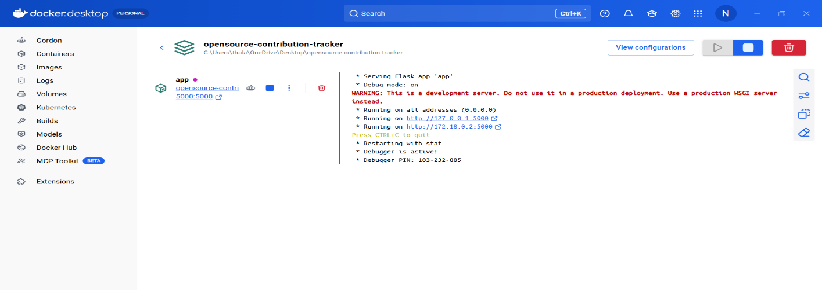
PAGE 9 – 9. DOCKER COMPOSE DESIGN
9.1 Purpose of Docker Compose
Docker Compose provides a structured way to define and run one or more related services.
For the current project, a minimal application service is sufficient. The configuration can later be extended with a database or notification service.
9.2 docker-compose.yml
services:
app:
build: .
ports:
- "5000:5000"
9.3 Configuration Explanation
Configuration | Explanation
services | Defines containers managed by Compose
app | Represents Flask application
build: . | Builds image using Dockerfile
ports | Maps host port 5000 to container port 5000
9.4 Future Extension
A future version can add:
- Database service
- Persistent volumes
- Environment variables
- Notification service
This supports a more scalable architecture.
[PASTE SCREENSHOT HERE]
Figure 7. Docker Compose configuration
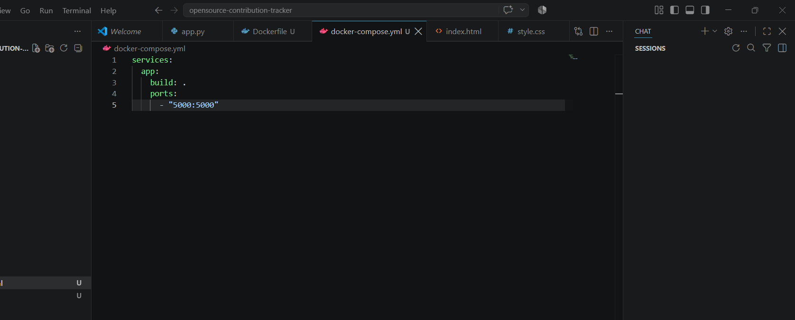

PAGE 10 – 10. CONTAINER DEPLOYMENT AND TESTING
10.1 Deployment Procedure
- Build the Docker image from the project root.
- Start the application container using Docker or Docker Compose.
- Verify that Flask listens on port 5000.
- Open the dashboard in a browser.
- Test the status, recommendation, and contribution endpoints.
- Verify that dashboard displays recommendation and contribution results.
10.2 Application Tests
Test | Expected Result | Evidence
Dashboard route | Dashboard loads successfully | Screenshot
/api/status | Success response | Screenshot
/api/recommend?skills=Python,Java | Matching issues returned | Screenshot
/api/contributions | Contribution records returned | Screenshot
Dashboard buttons | Results appear | Screenshot
10.3 Implementation Evidence
[PASTE SCREENSHOT HERE]
Figure 8. Flask application / Docker container running successfully
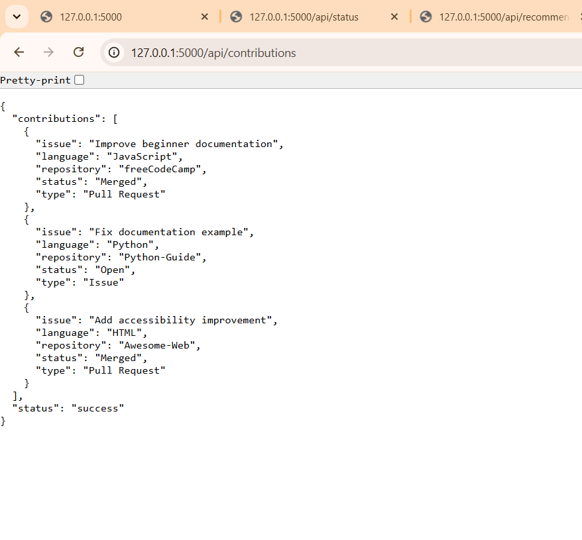
[PASTE SCREENSHOT HERE]
Figure 9. Final Open-Source Contribution Tracker dashboard
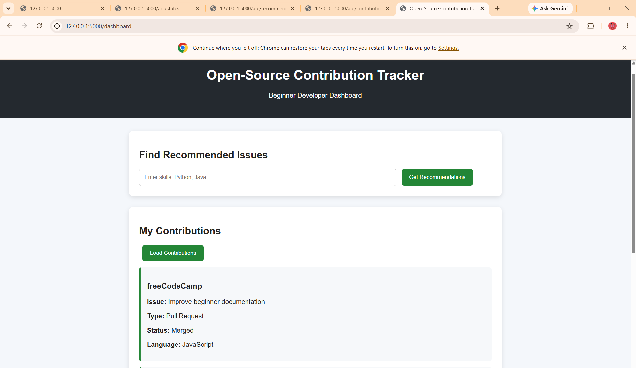

PAGE 11 – 11. BENEFITS AND FUTURE IMPROVEMENTS
11.1 Benefits of Git and Docker
Area | Benefit
Collaboration | Git tracks development activities
Version Management | Commits preserve project history
Portability | Docker provides consistent environment
Deployment | Containerization simplifies deployment
Maintainability | Modular structure makes changes easier
Scalability | Docker Compose supports additional services

12. CHALLENGES AND IMPROVEMENTS
12.1 Challenges Encountered
- Connecting Flask backend with frontend assets.
- Organizing recommendation logic into an independent module.
- Handling Python module paths correctly.
- Designing a simple recommendation mechanism.
- Preparing the application for containerized execution.
12.2 Future Improvements
- Integrate live GitHub API.
- Add user authentication.
- Add persistent user profiles.
- Use advanced recommendation algorithms.
- Add real-time notifications.
- Add portfolio generation.
- Add mentorship and project responsiveness indicators.
- Deploy the application to a cloud platform.
12.3 Limitations
The current prototype demonstrates the core recommendation and contribution-tracking workflow using application data.
Live GitHub synchronization, authentication, notification delivery, and production deployment can be implemented as future enhancements.

SYSTEM ARCHITECTURE
Figure 10. System architecture of the Open-Source Contribution Tracker
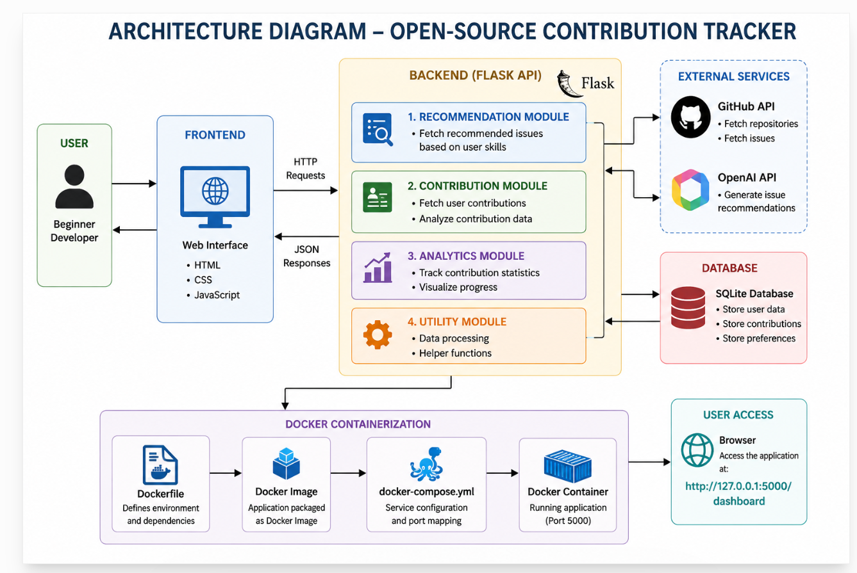

CONCLUSION
The Open-Source Contribution Tracker and Recommendation System provides a structured approach for beginner developers to discover suitable contribution opportunities and track their open-source activity.
The project separates the frontend, Flask backend, recommendation logic, and contribution data into maintainable components.
Git provides version control and a clear development history, while Docker provides a consistent environment for future deployment.
The prototype establishes a foundation that can be extended with live GitHub data, advanced recommendation techniques, notifications, authentication, and portfolio generation.
REFERENCES
- Git Documentation – Version control concepts and Git commands.
- Docker Documentation – Containers, images, Dockerfile, and Docker Compose.
- GitHub Documentation – Issues, labels, pull requests, and repository workflows.
- Flask Documentation – Web application routing and request handling.
- Python Documentation – Python language and package management.
- Software Engineering Course Assignment – CO3 Assessment Tool 1 – Git & Docker Technical Assignment.

